**DESIGNING AND OPTIMIZATION OF METAL CARBIDES AND SULPHIDES FOR ELECTRODES IN HYBRID SUPERCAPACITOR   
  
A PROJECT REPORT**

*Submitted in partial fulfillment of the*

*requirements for the award of the degree*

***of***

**BACHELOR OF TECHNOLOGY**

*By*

**Ishan Mohan Shrivastava**

**(210005021)**

*under the guidance of*

**Prof. Rupesh S. Devan** **DEPARTMENT OF METALLURGICAL ENGINEERING AND MATERIALS SCIENCE  
INDIAN INSTITUTE OF TECHNOLOGY INDORE**

**Autumn Semester, 2024**

|  |  |
| --- | --- |
| **C:\Users\TAPESH\Desktop\desktop\Logo - IITI\IIT Logo2.png** | **INDIAN INSTITUTE OF TECHNOLOGY INDORE** |

**CANDIDATE’S DECLARATION**

I hereby declare that the project entitled **“SYNERGISTIC DESIGN AND OPTIMIZATION OF 2D-Mn3O4/2D-MXene (Ti3C2-F) NANOCOMPOSITES FOR HIGH-PERFORMANCE HYBRID SUPERCAPACITOR ELECTRODES”** submittedin partial fulfillment for the award of the degree of Bachelor of Technology in ‘Metallurgical Engineering and Materials Science’ completed under the supervision of **Prof. Rupesh S. Devan, MEMS Department,** IIT Indore is an authentic work.

The matter presented has not been submitted by me for the award of any other degree at this or any other institute.

Yours Sincerely,

Ishan Mohan Shrivastava

**CERTIFICATE by BTP Guide**

It is certified that the above statement made by the students is correct to the best of my/our knowledge.

**Prof. Rupesh S. Devan**

Signature with date

**ACKNOWLEDGEMENTS**

My sincere appreciation goes out to our B.Tech project supervisor, Professor Rupesh S. Devan, for his steadfast encouragement and insightful criticism. Outside of the lab, his eagerness to participate in conversations and provide intelligent commentary greatly improved our chances of success.

Additionally, I am grateful to the lab members for their assistance and support, which made this trip unforgettable. In particular, I appreciate Ms. Ekta Choudhary, Dr. Santosh Bimli, Ms. Manopriya Samtham, Mr. Ajay Patil, Ms. Suman Yadav, Mr. Ankit Yadav, Ms. Aayushi Miglani Mr. Rishav Sharma, and Dr. Harshada Jadhav.

Finally, I would like to express our sincere gratitude to Mr. Mayur Dhake and the MEMS department for providing the facilities necessary for our study.

**Ishan Mohan Shrivastava**  
B. Tech IV year  
MEMS

**Abstract**

In this study, we present the synthesis, characterization, and electrochemical evaluation of MXene-based nanocomposites for hybrid supercapacitor electrodes. Initially, the Ti₃AlC₂ MAX phase was transformed into Ti₃C₂-F MXene via HF etching. MnO₂/MXene nanocomposites were then synthesized using the hydrothermal method. Two specific nanocomposites, prepared by combining 50 mg of MXene with 80 mg of KMnO₄, were subjected to heat treatment at 120 ℃. The electrochemical performance of these materials was analyzed through cyclic voltammetry (CV) and galvanostatic charge-discharge (GCD) techniques.

GCD results revealed specific capacitance variations across the three samples: MXene (Ti₃C₂-F), untreated MnO₂/MXene, and heat-treated MnO₂/MXene, with discharge times of 18.258 s, 23.904 s, and 29.298 s, respectively. Similarly, CV analysis showed peak currents of 0.229 A, 0.236 A, and 0.259 A for the same samples. The heat-treated MnO₂/MXene nanocomposite exhibited the highest performance, demonstrating the significant impact of heat treatment on enhancing electrochemical properties.

These findings underscore the potential of MXene-based nanocomposites, particularly with optimized treatments, for advancing the design of high-performance hybrid supercapacitor electrodes.

**TABLE OF CONTENTS**

**List of Figures**

**List of Tables**

**Nomenclature**

**Acronyms**

**Chapter 1: Introduction**

1.1 Need for Energy Storage

1.2 What are Supercapacitors and why are they important?

1.3 Types of supercapacitors

1.4 Literature Review for Mn3O4 growth on MXene.

1.4.1 MXene as 2D materials for high-performance supercapacitors

1.4.2 Mn3O4 – MXene nanocomposites in the context of supercapacitors  
 1.4.3 NiCoMnS4 nanostructures for high-performance hybrid supercapacitors electrodes

1.5 Research Gaps

1.6 Objectives

**Chapter 2: Experimental Section**

2.1 Synthesis of MXene (Ti3C2-F)

2.2 Synthesis of MXene (Ti3C2-F) – Mn3O4 nanocomposites

2.3 Synthesis of NiCoMnS₄ Nanoparticles

2.4 Materials Characterization

2.4.1 X-Ray Diffraction (XRD)

2.4.2 Field Emission Scanning Electron Microscopy (FESEM)

2.4.3 Brunauer-Emmett-Teller (BET) Surface Area

2.5 Electrochemical Characterization

2.5.1 Cyclic Voltammetry (CV)

2.5.2 Galvanostatic Charge Discharge (GCD)

**Chapter 3: Results and Discussion**

3.1 XRD results

3.1.1 MXene (Ti3C2-F) – Mn3O4 nanocomposites  
 3.1.2 NiCoMnS₄ Nano particles  
3.2 FESEM results  
 3.2.1 MXene (Ti3C2-F) – Mn3O4 nanocomposites  
 3.2.2 NiCoMnS₄ Nano particles

3.3 Cyclic Voltammetry results  
 3.3.1 MXene (Ti3C2F) – Mn3O4 nanocomposite  
 3.4 Galvanostatic Charge/Discharge Analysis   
 3.4.1 MXene (Ti3C2F) – Mn3O4 nanocomposite  
 3.4.2 Calculations

**Chapter 4: Conclusion and Future Scope**

4.1 Conclusion

4.2 Future Scope

**List of Figures**

**Figure 1**: Schematic of Supercapacitor

**Figure 2**: XRD of MXene (Ti₃C₂-F) – Mn₃O₄ nanocomposites

**Figure 3**: XRD of NiCoMnS₄ Nano Particles

**Figure 4**: FESEM micrographs of MXene (Ti₃C₂-F) – Mn₃O₄ nanocomposites

* (a) 50 mg MXene + 80 mg KMnO₄ Sample; Heat treated at 120 °C; Magnification = 4000X
* (b) 50 mg MXene + 80 mg KMnO₄ Sample; Heat treated at 120 °C; Magnification = 25,000X
* (c) MXene (Ti₃C₂-F); Magnification = 5000X
* (d) MXene (Ti₃C₂-F); Magnification = 25,000X
* (e) 50 mg MXene + 80 mg KMnO₄ Sample; Magnification = 4000X
* (f) 50 mg MXene + 80 mg KMnO₄ Sample; Magnification = 25,000X

**Figure 5**: FESEM micrographs of NiCoMnS₄ Nano Particles

* (a) Precursor ratio: N:C: M:S = 1:1:1:8; Magnification = 2700X
* (b) Precursor ratio: N:C: M:S = 1:1:1:8; Magnification = 10,000X

**Figure 6**: CV graphs of MXene (Ti₃C₂-F) and Mn₃O₄ nanocomposites

* (a) CV graph of 50 mg MXene + 80 mg KMnO₄ Sample
* (b) CV graph of MXene (Ti₃C₂-F)
* (c) CV graph of 50 mg MXene + 80 mg KMnO₄ Sample; Heat treated at 120 °C

**Figure 7**: CV graphs at 100 mV/s

* (a) CV graph of 50 mg MXene + 80 mg KMnO₄ Sample
* (b) CV graph of MXene (Ti₃C₂-F)
* (c) CV graph of 50 mg MXene + 80 mg KMnO₄ Sample; Heat treated at 120 °C

**Figure 8**: GCD graphs of MXene (Ti₃C₂-F) and Mn₃O₄ nanocomposites

* (a) GCD graph of 50 mg MXene + 80 mg KMnO₄ Sample
* (b) GCD graph of MXene (Ti₃C₂-F)
* (c) GCD graph of 50 mg MXene + 80 mg KMnO₄ Sample; Heat treated at 120 °C

**Figure 9**: GCD graphs at 1 A/g

* (a) GCD graph of 50 mg MXene + 80 mg KMnO₄ Sample
* (b) GCD graph of MXene (Ti₃C₂-F)
* (c) GCD graph of 50 mg MXene + 80 mg KMnO₄ Sample; Heat treated at 120 °C

**Figure 10**: Specific Capacitance vs. Current Density Graphs

* (a) 50 mg MXene + 80 mg KMnO₄ Sample
* (b) MXene (Ti₃C₂-F)
* (c) 50 mg MXene + 80 mg KMnO₄ Sample; Heat treated at 120 °C

**List of Tables**

**Table 2.1**: Different composites containing MXene and KMnO₄ precursors in different ratios

**Table 2.2**: Weights of precursors taken in synthesizing NiCoMnS₄

**Table 2.3**: Precursors’ ratio taken for all the additional samples prepared of NiCoMnS₄

**Table 3.1**: List of samples for MXene (Ti₃C₂-F) – Mn₃O₄ nanocomposites and their compositions

**Table 3.2**: Parameters for the preparation of NiCoMnS₄ nanoparticles

**Acronyms and Abbreviations**

**BET**: Brunauer-Emmett-Teller

**BTP**: Bachelor of Technology Project

**CV**: Cyclic Voltammetry

**DFT**: Density Functional Theory

**EDLC**: Electrical Double Layer Capacitor

**FESEM**: Field Emission Scanning Electron Microscopy

**GCD**: Galvanostatic Charge-Discharge

**HSC**: Hybrid Supercapacitor

**MAX**: Mₙ₊₁AXₙ Phase (where M is a transition metal, A is an A-group element, and X is carbon/nitrogen)

**MXene**: Two-dimensional transition metal carbides, nitrides, or carbonitrides

**NiCoMnS₄**: Nickel Cobalt Manganese Sulfide

**SCE**: Saturated Calomel Electrode

**XRD**: X-Ray Diffraction

**HF**: Hydrofluoric Acid

**DI**: Deionized (water)

**NaOH**: Sodium Hydroxide

**KMnO₄**: Potassium Permanganate

**Ti₃C₂-F**: Fluorinated Ti₃C₂ MXene

**Mn₃O₄**: Manganese Oxide (in specific nanostructure forms)

**CHAPTER 1**

**INTRODUCTION**

**1.1. Need for energy storage:**

Energy storage is the capability of storing energy for later use, such a capability is exploited via energy storage devices like batteries, capacitors, supercapacitors, flywheels, compressed energy storage devices, pumped hydro storage devices, etc.

These energy storage devices are needed to reduce our dependence on backup devices like fuel generators that rely completely on the combustion of fossil fuels. Present day world is facing harmful repercussions due to the excessive usage of fossil fuels. Combustion of these fossil fuels releases greenhouse gasses into our atmosphere which lead to global warming which further leads to environmental degradation of our biosphere. To tackle this problem scientists and researchers are giving their efforts to develop reliable energy storage devices like batteries and supercapacitors. These are reliable power sources that decrease our dependence on fossil fuels.

Batteries have their advantages but they have some drawbacks too, for example, Li-ion batteries are lightweight, have a high energy density, have minimal energy loss, etc., but they have some disadvantages like higher cost, hazardous due to toxicity, etc. Batteries are unable to provide energy at a rapid rate in other words they don't have a high power density. Hence batteries alone can’t be used in high power applications like EV vehicles.

This problem can be solved by the usage of supercapacitors.

**1.2. What are supercapacitors and why are they important?**

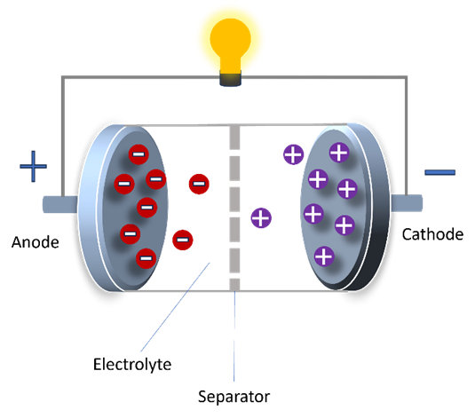

**Fig 1.** Schematic of Supercapacitor

Supercapacitors, otherwise ultra-capacitors or electrochemical capacitors, store energy devices that hold intermediate properties between a battery and a traditional capacitor. They shall be known as devices capable of storing and releasing energy in an extremely short period, making them therefore very appropriate for applications requiring fast charge and discharge cycles. Supercapacitors are nowadays used in various applications due to their unique properties like high power density, rapid charging and discharging, long life cycle, and wide temperature range. The structure of supercapacitors include a separator, an electrolyte, two current collectors, anode, and cathode materials.

Supercapacitors charge by electrostatic separation. They have two electrodes drenched in an electrolyte with a dielectric separator in between. When a voltage is applied, ions move down the electrolyte toward the electrodes and start building up an electric double layer. Such charge separation then allows fast energy storage and release.

**1.3** **Types of supercapacitors**

There are three types of supercapacitors, they are as follows -

1. **EDLC (Electrical double-layer capacitor)**

Electrochemical double-layer capacitors store energy electrostatically, with high-surface-area carbon electrodes in an electrolyte, featuring a separator and metal current collectors. On application of a voltage, the ions form a double layer at the electrode surfaces and thus allow fast charge/discharge cycles in EDLCs. They have high power density, long life, and quick charging, with lower energy density compared to batteries. Applications include automotive, consumer electronics, industrial power backup, and renewable energy.

1. **Pseudo Supercapacitors**

Most of the charge storage in pseudo capacitors occurs through faradaic processes such as electro-sorption, redox reactions, and intercalation, while some charge storage is also due to electrical double layer formation, but it is negligible as compared to the charge storage due to faradaic processes. When an external voltage is applied, these fast and reversible redox reactions take place on the electrode, transferring charges between the electrode and the electrolyte. This charge and discharge mechanism is similar to that of batteries.

1. **Hybrid Supercapacitors**

Hybrid supercapacitors combine EDLCs and pseudo-capacitors to increase both power and energy density. The anode is prepared with metal oxides or conducting polymers that store energy through faradaic reactions, while the negative electrode is made from high-surface-area carbon material storing energy electrostatically. Thus, a highly dense energy device with fast charging and yet high power density with a long cycle life is realized—exactly what is required in automotive systems, consumer electronics, industrial applications, and renewable energy.

**1.4 Literature Review for Mn3O4 growth on MXene.**

**1.4.1 MXene as 2D materials for high-performance supercapacitors**

MXenes are a type of 2D materials recently discovered to be appropriate for most dynamic and technologically advanced uses. Usually, it exists as transitional metal nitrides and/or Carbides sharing a similar formula Mnn +1XnTz have M, X, and Tz as the early transition metal elements; nitrogen and/or carbon, and surface limiting groups correspondingly depending on n = 1, 2, or 3. MXenes are a fascinating class of two-dimensional (2D) materials drawing great attention with their probable uses in supercapacitors. MXenes mix great surface area and customized chemical properties with strong electrical conductivity from transition metal carbides, nitrides, or carbonitrides.   
Particularly supercapacitors, which depend on materials with high power and energy densities, these characteristics make them ideal candidates for energy storage technologies. The unique layered structure of MXenes makes simple ion intercalation easier, hence enhancing charge storage capacity. Their hydrophilicity also helps to promote electrolyte interaction, which increases performance much more. Recent focus has been on the remarkable capacitance and cycling stability of MXene-based supercapacitors, which show capacity over thousands of charge-discharge cycles. As scientists keep exploring the synthesis and functionalization of MXenes, their possibility in next-generation energy storage solutions becomes increasingly fascinating. [2]

**1.4.2 Mn3O4 – MXene nanocomposites in the context of supercapacitors**

The Ti3C2-Mn3O4 nanocomposite is a promising material for energy storage devices, particularly as a supercapacitor electrode. Synthesized through a cost-effective two-step solvothermal process at 150°C, this composite exhibits impressive electrochemical performance. It achieves a maximum specific capacity of 128 mAh g−1 at a current density of 1 A g−1 in a 6 M KOH aqueous electrolyte. The material demonstrates excellent cycling stability, retaining 77.7% of its capacity after 2000 cycles at 10 A g−1, and maintains an energy efficiency of 83.5%.

Furthermore, when integrated into a hybrid supercapacitor device with carbonized iron cations (C-FP), it delivers a specific capacity of 78.9 mAh g−1 and an energy density of 28.3 Wh kg−1 with a power density of 463.4 W kg−1 at 1 A g−1. The device also shows remarkable cycling stability, with 92.6% capacity retention over 10,000 cycles at 3 A g−1. This synergy of features makes the Ti3C2-Mn3O4 nanocomposite a highly effective material for advanced energy storage applications.

**1.4.3 NiCoMnS4 nanostructures for high-performance hybrid supercapacitor electrodes**

Mesoporous Ni-Co-Mn sulfide is synthesized as the electroactive battery material for hybrid supercapacitors (HSCs), demonstrating strong synergy in electrochemistry for charge storage. The synergistic interaction between the transition metals in NiCoMn-S was investigated through a combination of density functional theory (DFT) calculations and experimental analysis. These studies compared the charge storage properties of sulfides with different transition metals. The results indicate that the Mn composition plays a critical role by activating the 3d electrons of Co and enhancing the affinity of NiCo-S with electrolyte ions, which leads to improved electrochemical activity and rate performance. Additionally, the inclusion of Mn increases the specific surface area, providing more electroactive sites and reducing the charge transfer resistance of NiCo-S. The combined contributions from the transition metals in NiCoMn-S result in enhanced specific capacity, high rate performance, and excellent cycling stability, making it a promising material for energy storage applications. Transition tri-metallic sulfide NiCoMn–S gets great attention because of its high specific capacity for hybrid supercapacitors and Ti3C2 is mostly considered as a promising new electrode material with characteristic two-dimensional layered structure and remarkable conductivity.

Herein, a basic one-step hydrothermal approach is used to composite two-dimensional layered Ti3C2 with NiCoMn–S nanoparticles first applied as positive electrode found in hybrid supercapacitors (HSCs). Many NiCoMn–S nanoparticles either even reach into the Ti3C2 layers or distribute on the surface of Ti3C2, providing plenty of electrochemical active sites for redox reactions and hence enhancing the mechanical stability of composites. Moreover, the NiCoMn–S/Ti3C2 composites show lower charge-transfer resistance than pure NiCoMn–S, thereby suggesting that the two-dimensional layered structure of Ti3C2 improves conductivity and offers additional electronic channels for ion transit. NiCoMn–S/Ti3.4% offers a specific capacity of 347.1 C g̓, 28% greater than that of pure NiCoMn–S (270.2 C g̓) at a given density of 1 A g-1.[4]

**1.5 Research Gaps**

A lot of research has been done in this area, but there are still important areas that need more research. Some important study gaps that need to be filled are:

1. Looking into how to mix different materials to greatly raise energy and power density can help energy storage systems work better.
2. Design using composite synthetics: to find fresh approaches to raise the already high specific capacitance of MXenes. This includes creating novel hybrid materials using cooperative strength-building that improve performance with electricity and chemicals.
3. Getting ready the best morphological pairs: researching extensively to identify and enhance the greatest approaches to combine the forms of several materials.[3]

**1.6 Objectives**

The following are the objectives to fill up the above-mentioned research gap:

1. To synthesize MXene (Ti3C2-F), for developing its composites with Mn oxides like Mn3O4.
2. To synthesize MXene – Mn3O4 nanocomposites for electrodes in Hybrid supercapacitors.
3. Material and electrochemical characterizations of MXene and MXene – Mn3O4 nanocomposites.

**CHAPTER 2**

**EXPERIMENTAL SECTION**

**2.1 Synthesis of MXene (Ti3C2-F)**

The Ti3AlC2 MAX phase was used to produce a two-dimensional layered Ti3C2-F MXene by HF etching method. One gram of Ti3AlC2 MAX phase was mixed with twenty milliliters of 40% hydrofluoric acid (HF, SRL Chemicals) and let to react under a controlled temperature of 50 °C for twenty-four hours with continuous stirring. Subsequently, the pH of the reaction mixture was promptly neutralized by the addition of deionized water and centrifuged at 4000 rpm in conjunction with ethanol.

The resultant Ti3C2-F MXene was studied during overnight drying at 70 °C (Fig. 1). This procedure yielded ≥85% of the Ti3C2-F MXene from the pure MAX phase. Furthermore, an extra delamination process utilizing lithium chloride salt was not implemented in this study to achieve well-separated and stacked Ti3C2-F MXene sheets.

**2.2 Synthesis of MXene (Ti3C2-F) – Mn3O4 nanocomposites**

MnO₂/MXene nanocomposites were synthesized using the hydrothermal method. Initially, 30 mL of deionized (DI) water was measured and added to a cleaned beaker, followed by the addition of 50 mg of MXene. A magnetic needle was placed into the solution, and the mixture was stirred for 10–15 minutes at room temperature. Separately, 80 mg of KMnO₄ was measured and added to the MXene suspension, and the resulting mixture was stirred at 90°C for 30 minutes. The stirred solution was then transferred to a Teflon-lined autoclave, which was sealed and placed in an electric furnace.

The temperature was raised to 140°C at a ramp rate of 3°C/min, and the reaction was allowed to proceed for 4 hours. Upon completion, the autoclave was cooled, and the clear supernatant was carefully removed. The solid product was washed thoroughly using centrifugation with DI water and ethanol, at A RPM of 4000 rpm, followed by vacuum drying at 60°C for 4 hours. More additional samples were synthesized by varying the amount of MXene, KMnO₄, and the drying time to explore the effect of MXene concentration on the composite formation and its electrochemical properties. These are shown in the following table (Table 1.1):

**Table 2.1:** Different composites containing MXene and KMnO4 precursors in different ratios

|  |  |  |
| --- | --- | --- |
| **Sample Number** | **Composition** | **Drying temperature** |
| 1 | 10 mg MXene + 80 mg KMnO4 | 60℃ |
| 2 | 10 mg MXene + 80 mg KMnO4 | 120℃ |
| 3 | 20 mg MXene + 80 mg KMnO4 | 60℃ |
| 4 | 20 mg MXene + 80 mg KMnO4 | 120℃ |
| 5 | 50 mg MXene + 80 mg KMnO4 | 60℃ |
| 6 | 50 mg MXene + 80 mg KMnO4 | 120℃ |
| 7 | 50 mg MXene + 50 mg KMnO4 | 60℃ |
| 8 | 50 mg MXene + 50 mg KMnO4 | 120℃ |

**2.3 Synthesis of NiCoMnS₄ Nanoparticles**

The NiCoMnS4 nanostructures were synthesized through a hydrothermal process. Initially, four cleaned beakers were prepared, and 10 mL of deionized (DI) water was added to each using a dropper and a cleaned measuring cylinder. The respective masses of the precursor materials were then added to the beakers (weights taken are shown in Table 1.2 (NCMS 1)). Cleaned magnetic stir bars were introduced to all four beakers, and the solutions were stirred using a magnetic stirrer for 5 minutes. Subsequently, the contents of all four beakers were combined dropwise into a single beaker while maintaining continuous stirring. The combined solution was stirred for an additional 5 minutes. The final mixture was then transferred to a cleaned Teflon liner (50 mL capacity) and sealed within a stainless steel autoclave. The autoclave was placed in an electric furnace, and the following parameters were maintained: ramp rate of 3 °C/min, final temperature of 180 °C, and reaction time of 12 hours. After 12 hours, the furnace was switched off, and the autoclave was allowed to cool to room temperature before opening. Upon opening, the

NiCoMnS4 powder was observed at the bottom of the Teflon liner, with a transparent fluid floating above it. The fluid was carefully removed using a dropper. The remaining solution was transferred to a cleaned centrifugation tube and subjected to centrifugation under the following conditions: 5 cycles with DI water at 4000 RPM for 5 minutes each, followed by 1 cycle with ethanol at 4000 RPM for 5 minutes. After centrifugation, the ethanol was discarded, and fresh ethanol was added.

The solution was then collected in a cleaned petri dish, covered with aluminum foil with perforations to allow ethanol to evaporate, and subjected to vacuum drying at 80 °C for 2 hours under a vacuum of -900 PV. After drying, the heater was switched off, and the furnace was allowed to cool to room temperature before the sample was collected in a vial. Some additional samples were prepared under identical conditions using different precursor ratios, to explore the effect of increasing Manganese’s ratio in the final composition on the composite formation and its electrochemical properties. [1]

**Table 2.2**: Weights of precursors taken in synthesizing NiCoMnS4

|  |  |  |  |  |
| --- | --- | --- | --- | --- |
| **Precursor** |  | **Molarity (mM)** |  | **Mass taken (mg)** |
| Ni(NO3)2.6H2O |  | 0.8 |  | 9.30 |
| Co(NO3)2.6H2O |  | 0.8 |  | 9.31 |
| Mn(NO3)2.4H2O |  | 0.8 |  | 8.03 |
| Na2S |  | 6.4 |  | 19.97 |

Table 2.3 (shown below) shows the precursor’s ratio taken for all the additional samples prepared.

**Table 2.3:** The precursors’ ratio taken for all the additional samples prepared of NiCoMnS4

|  |  |  |
| --- | --- | --- |
| **Sample Number** | **Precursors’ ratio ( Ni:Mn:Co:S)** | **Temperature of drying/ annealing** |
| 1 | 1 : 1 :1 : 8 | 80 ℃ |
| 2 | 1 : 1.1 : 1 : 8 | 80 ℃ |
| 3 | 1 : 1.2 : 1 : 8 | 80 ℃ |
| 4 | 1 : 1.5 : 1 : 8 | 80 ℃ |
| 5 | 1 : 1.5 : 1 : 8 | 150 ℃ |
| 6 | 1 : 1.5 : 1 : 8 | 180 ℃ |

**2.4 Materials Characterization** **2.4.1 X-Ray Diffraction (XRD):**

X-ray diffraction (XRD) can provide the structural and phase information of a crystalline sample. The sample's crystal structure functions as a three-dimensional diffraction grating when monochromatic X-rays are focused at it, due to the interplanar spacing of atomic planes being comparable to the wavelength of the X-rays. Elastic scattering of X-rays produces constructive interference at given diffraction angles. Bragg's law, more especially, numerically expresses this by explicitly

nλ = 2dhklSin(θ)

λ is the incident X-ray wavelength; dhkl is the interplanar spacing; θ is the angle of incidence. Recordings of the strength of diffracted photons at various angles provide information on crystal structure and phase. Empyrean XRD equipment from Malvern-Panalytical was used in XRD experiments at a wavelength of λ = 1.5406 Å.

**2.4.2 Field Emission Scanning Electron Microscopy (FESEM):**

Fourier transform electron microscopy (FESEM) is a technology that is used to investigate the morphological characteristics of a sample. It accomplishes this by providing a picture of the sample at magnifications and resolutions that are orders of magnitude higher than those of conventional optical microscopes.

Free electron scanning electron microscopy (FESEM) makes use of electrons, in contrast to optical microscopy, which makes use of visible light. When compared to standard scanning electron microscopy (SEM), FESEM is distinguished by the fact that it generates electron beams through the utilization of powerful electric fields, in contrast to SEM, which makes use of thermionic emission. Through the utilization of magnetic lenses, the electron beam that has been generated is concentrated onto the sample. These incident electrons are secondary electrons and auger electrons from the sample, in addition to a certain number of backscattered electrons. These electrons can be detected and transformed into electrical signals, which can then be examined based on the requirements. X-rays are also emitted by the material that is being sampled. The JEOL JSM-7610 F Plus FESEM was utilized in order to carry out the FESEM characterization tasks.

**2.4.3 Brunauer-Emmett-Teller (BET) Surface Area Analysis**:

The specific surface area and the distribution of pore size inside the sample are found using BET analysis. This could help us to approximate the overall count of the active sites in the sample. To entirely degas the sample that will be examined under a vacuum, it is heated steadily for a prolonged length of time. Injecting an inert gas, such as nitrogen, into the chamber, it is then let to adsorb on the surface of the sample.

Afterward, the surface area is determined by employing a plot that correlates the volume of adsorbed particles with the relative partial pressure. The BET analysis was performed with the assistance of a Quantchrome Autosorb iQ2 gas adsorption analyzer utilizing automated technology.

**2.5 Electrochemical Characterization:**

Electrochemical characterizations are carried out to evaluate the performance of the electrode material that has been manufactured. In most cases, the independent component is either the current or the potential, and it is the one that is modified. The response of the current or potential, which is the dependent component, is then measured and plotted to extract important information.

Two-electrode and three-electrode configurations are the most common types of electrical connections. A working electrode and a counter electrode are the components that make up a two-electrode configuration. This configuration is utilized to characterize electrochemical energy devices like batteries and supercapacitors, as well as in situations where the counter electrode maintains a constant voltage over the course of the experiment. To provide a more precise measurement of the individual potential changes that are taking place at the working electrode, it is common practice to employ a setup consisting of three electrodes. The working electrode, the counter electrode, and the reference electrode are the components that make up this device. Despite the potential changes that are taking place at the counter electrode, this is of tremendous use since it can be utilized to investigate the electrochemical processes that are taking place at the working electrode.

This is accomplished by measuring the potential difference that exists between the working electrode and the reference electrode. In this particular arrangement, the characterization of specific electrode materials was carried out using a three-electrode configuration, with SCE serving as the reference electrode. On the other hand, to conduct electrochemical characterization of the symmetric and asymmetric devices that were manufactured, a configuration consisting of two electrodes was utilized**.**

**2.5.1 Cyclic Voltammetry (CV):**

It is often employed in research to investigate material electrochemical properties, cyclic voltammetry (CV) is a potent electrochemical technique. By measuring how the current of an electrochemical cell changes as the potential moves linearly over time, CV offers us significant fresh ideas on the kinetics and thermodynamics of redox reactions. This method is particularly valuable in fields including battery technology, supercapacitors, corrosion studies, and sensor development.

A standard CV experiment uses a three-electrode system consisting of a working electrode, a reference electrode, and a counter electrode. The reference electrode maintains constant voltage; the redox events occur on the working electrode. The counter electrode closes the circuit by letting the current pass. To generate a cyclic voltammogram, a graph displaying the voltage-current relationship, the potential is cycled between predetermined boundaries. Usually, the resulting voltammogram shows discrete peaks matching to oxidation and reduction processes. Through peak analysis, researchers can extract essential data such as peak currents, peak potentials, and the area under the curve, so related to the charge transferred during the reaction. CV can also expose vital properties including reaction reversibility and electron transport rates.   
The specific capacitance of the material can be calculated by using the area enclosed by the corresponding CV curve. Mathematically,

Where is the specific capacitance (F/g), is the current during forward (or backward) voltage sweep (A), V1 and V2 are the potential bounds (potential swept from V1 to V2 during forward sweep and V2 to V1 during reverse sweep), (V), is the mass loading (g), is the scan rate (mV/s).

**2.5.2 Galvanostatic Charge Discharge (GCD):**

Galvanostatic charge-discharge (GCD) is a key electrochemical technique for evaluating the performance of batteries and supercapacitors among other energy storage technologies. This method lets researchers investigate many performance characteristics, including capacity, efficiency, and energy density, using a constant current to the device during charging and discharging cycles. First charged at a set current, the device in a GCD test reaches its maximum voltage. Once fully charged, the current is inverted to discharge the device back to minimum voltage. Plotting the resulting data as voltage against time reveals significant material under evaluation attributes.

Among other testing methods, GCD's ability to recreate real-world environments whereby devices run under continuous current demands is one of its key advantages. This clarifies for one how the parts will react in practical situations. Voltage hysteresis and internal resistance are crucial for maximizing battery design and improving general performance.

Specific capacitance can also be quantified by the discharge curve of GCD,

where, is the specific capacitance (F/g), is the mass loading of the electrode (g), is the potential window (V), and is the discharge current (A).

**CHAPTER 3**

**RESULTS AND**

**DISCUSSION**

**3.1 XRD Analysis  
 3.1.1 MXene (Ti3C2-F) – Mn3O4 nanocomposites  
 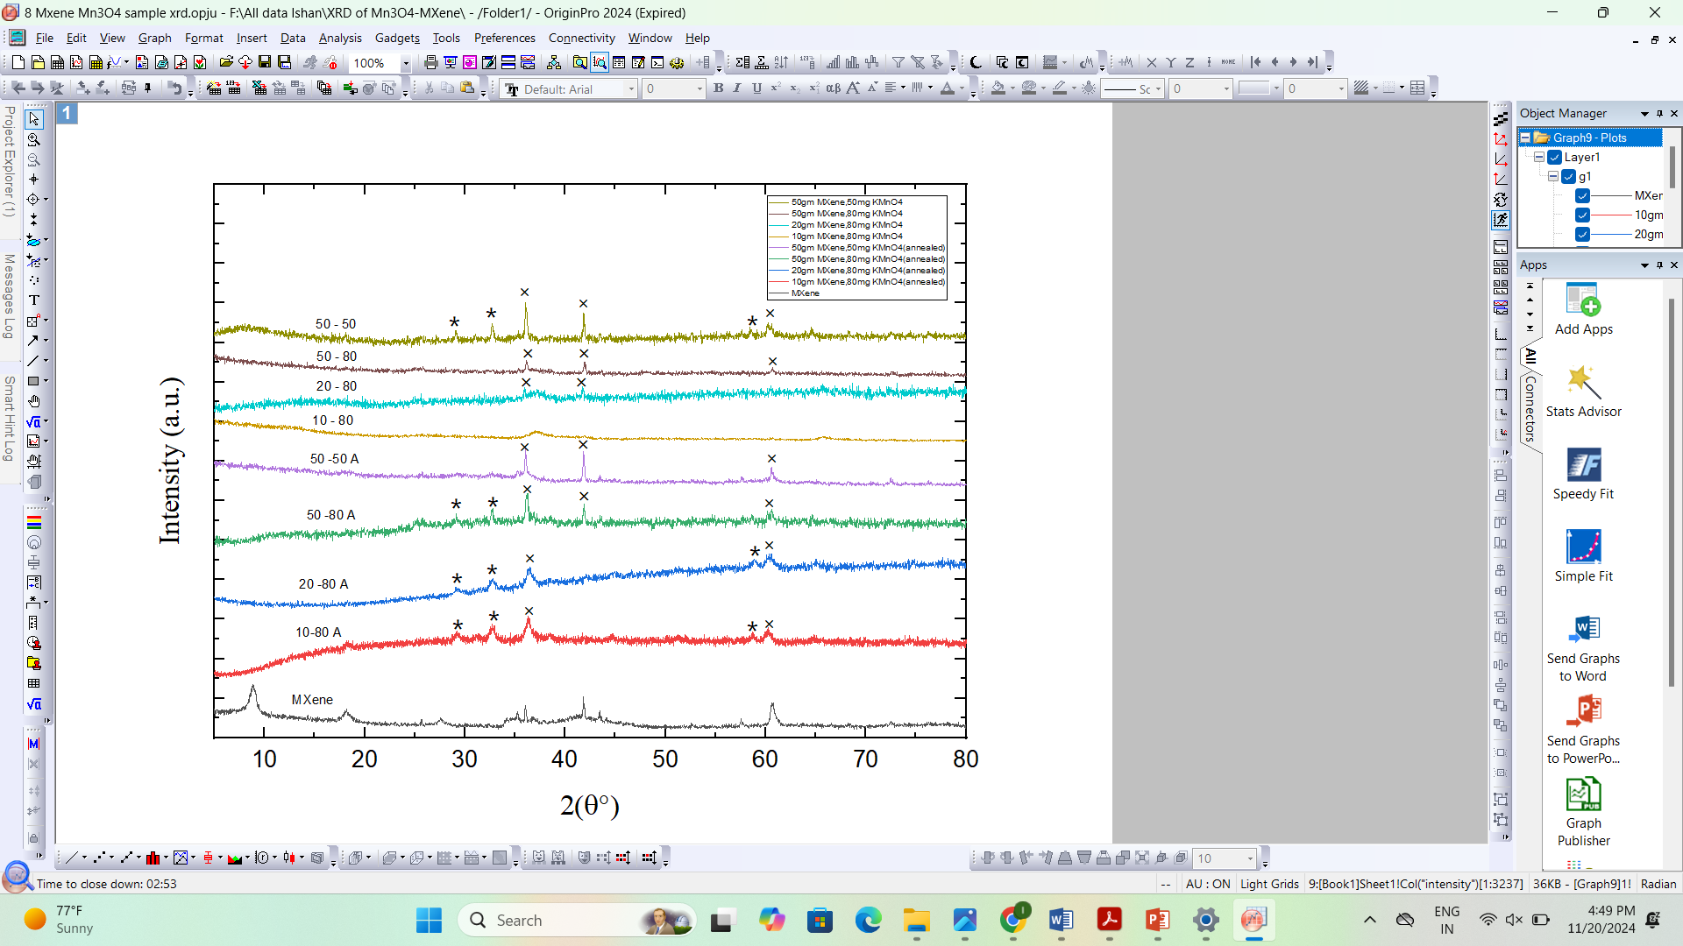**

**Fig 2**. XRD of MXene (Ti3C2F) – Mn3O4 nanocomposites

Here XRD of 9 samples are being reported, which are as follows,

**Table 3.1:** List of the samples

|  |  |  |  |
| --- | --- | --- | --- |
| Sample Number | Sample Name | Composition | Temperature of Drying |
| 1 | 50-50 | 50 mg MXene + 50 mg KMnO4 | 60℃ |
| 2 | 50-80 | 50 mg MXene + 80 mg KMnO4 | 60℃ |
| 3 | 20-80 | 20 mg MXene + 80 mg KMnO4 | 60℃ |
| 4 | 10-80 | 10 mg MXene + 80 mg KMnO4 | 60℃ |
| 5 | 50-50 A | 50 mg MXene + 50 mg KMnO4 | 120℃ |
| 6 | 50-80 A | 50 mg MXene + 80 mg KMnO4 | 120℃ |
| 7 | 20-80 A | 20 mg MXene + 80 mg KMnO4 | 120℃ |
| 8 | 10-80 A | 10 mg MXene + 80 mg KMnO4 | 120℃ |
| 9 | MXene | - | 50 ℃ |

The peaks denoted with ‘*’ signify the pristine Mn3O4 phase (JCPDS Card No. 24-0734). The peaks (112), (103), and (321) correspond to angles of 29.37°, 32.63°, and 58.73°, respectively. The peaks denoted by 'X' signify the MXene phase (Ti3C2-F). The included angles are (111) at 36.02°, (200) at 41.82°, and (220) at 60.7°. It can be observed that heat treatment at 120℃ often enhances the sharpness and intensity of the peaks, indicating an increase in the crystallinity of the Mn3O4 phase. An increase in the quantity of MXene within the powder composition results in more pronounced MXene peaks.

**3.1.2 NiMnCoS4 nanoparticles**

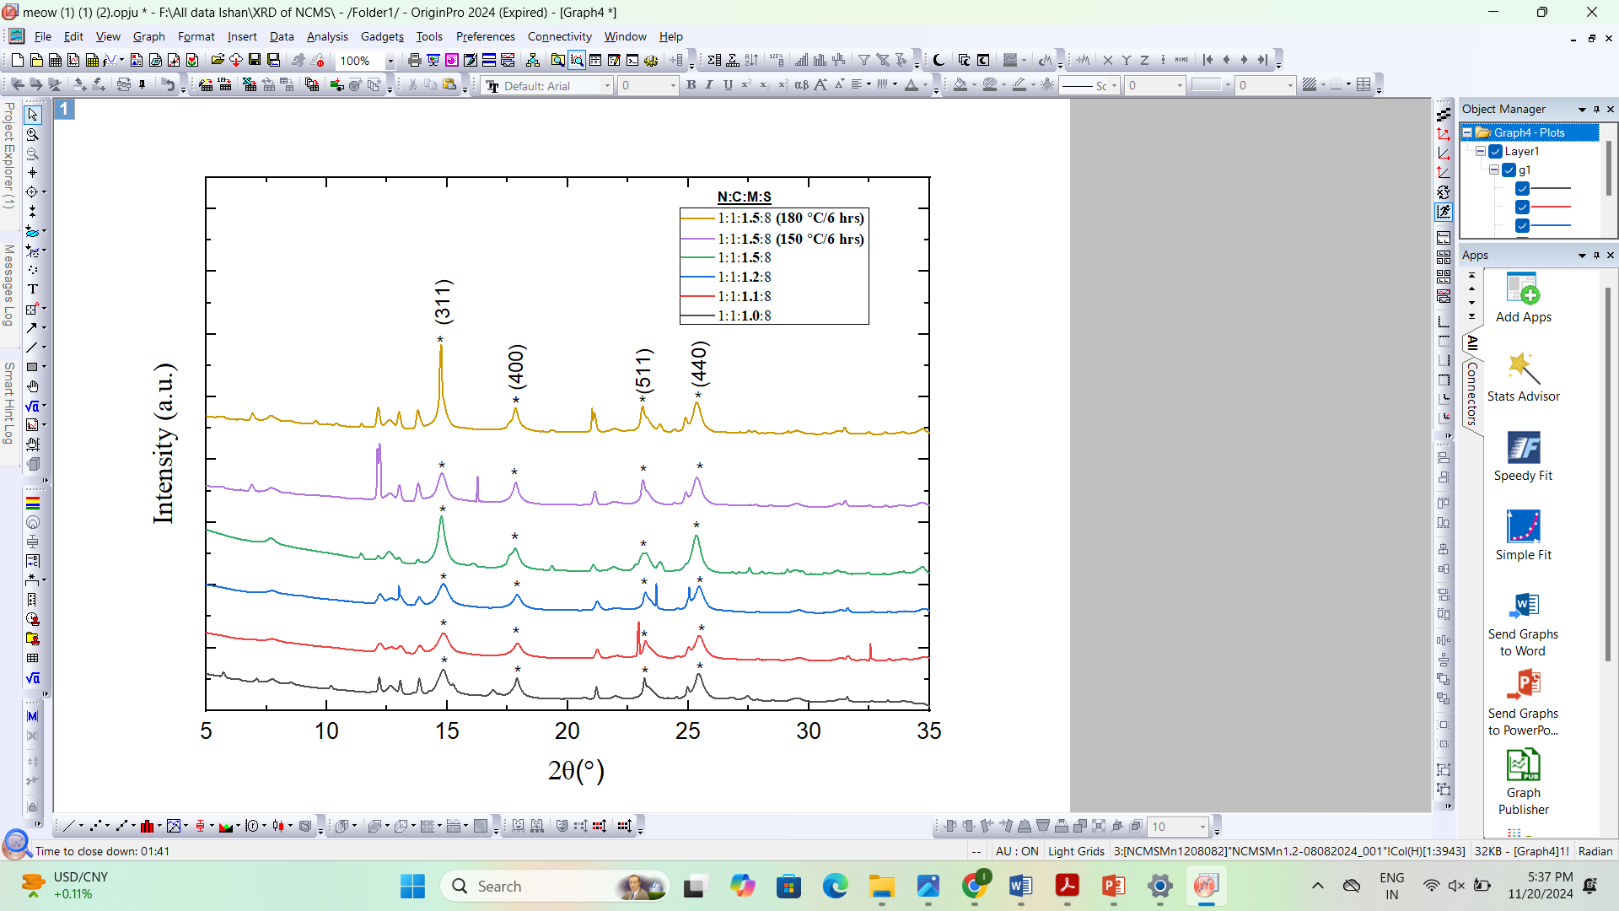

**Fig 3.** XRD of NiCoMnS4 Nano Particles

Here XRDs of 6 samples are being reported, the samples are the following:

**Table 3.2**: Parameters for same preparations.

|  |  |  |
| --- | --- | --- |
| Sample Number | Ratio of Precursors | Drying/annealing Temperature |
| 1 | 1: 1 : 1.5: 8 | 180℃ / 6 hrs |
| 2 | 1 : 1 : 1.5 : 8 | 150℃ / 6 hrs |
| 3 | 1 : 1 : 1.5 : 8 | 80℃ / 2 hrs |
| 4 | 1 : 1 : 1.2 : 8 | 80℃ / 2 hrs |
| 5 | 1 : 1 : 1.1 : 8 | 80℃ / 2 hrs |
| 6 | 1 : 1 : 1 : 8 | 80℃ / 2 hrs |

The peaks marked with ‘*’ indicate the NiCoMnS4 phase. The peaks (311), (400), (511), and (400) correspond to angles of 14.73°, 17.83°, 23.14°, and 25.37°, respectively. It is evident that as the ratio of Mn(NO3)2·4H2O increases, the peaks of NiCoMnS4 become more pronounced and sharper. To enhance crystallinity in our phase, annealing was conducted at 180℃ for 6 hours, resulting in the greatest intensity peaks seen.

**3.2 FESEM Analysis  
 3.2.1 MXene (Ti3C2-F)–Mn3O4 nanocomposites.**

**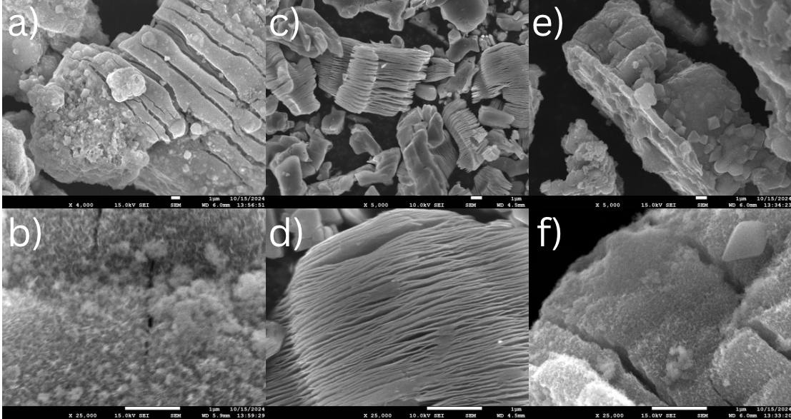  
  
Fig 4.** FESEM micrographs of (a) 50 mg MXene + 80 mg KMnO4 Sample; Heat treated at 120 ℃ ; M = 4000X (b) 50 mg MXene + 80 mg KMnO4 Sample; Heat treated at 120 ℃ ; M = 25,000X (c) MXene (Ti3C2F); M = 5000X (d) MXene (Ti3C2F); M = 25,000X (e) 50 mg MXene + 80 mg KMnO4 Sample; M = 4000X (f) 50 mg MXene + 80 mg KMnO4 Sample; M = 25,000X

The inclusion of Mn3O4 results in its incorporation in between the Ti3C2 sheets providing the Ti3C2-Mn3O4 nanocomposite mix in Figures 3a,3b,3e, and 3f. Furthermore acting as a conductive support platform for the aggregated Mn3O4 nanostructures, which will probably act as a nanoscale collector for electron transport, are the Ti3C2 nanosheets.

It is clear from Figures 3c and 3d that the as-prepared Ti3C2-F consists of a stacked sheet-like construction reminiscent of exfoliated graphite or transition metal oxides. The as-observed image validates the effective removal of the aluminum layer through the HF treatment producing a stacked Ti3C2-F accordion-like morphology which might improve the electrode/electrolyte interface hence enabling effective ionic transport and pseudo-capacitance performance.

One can also observe that on doing the heat treatment of the as-prepared MXene (Ti3C2-F)–Mn3O4 nanocomposite, the sheets of MXene get fused into each other forming thicker slab-like structures.

**3.2.2 NiCoMnS₄ Nano particles.**

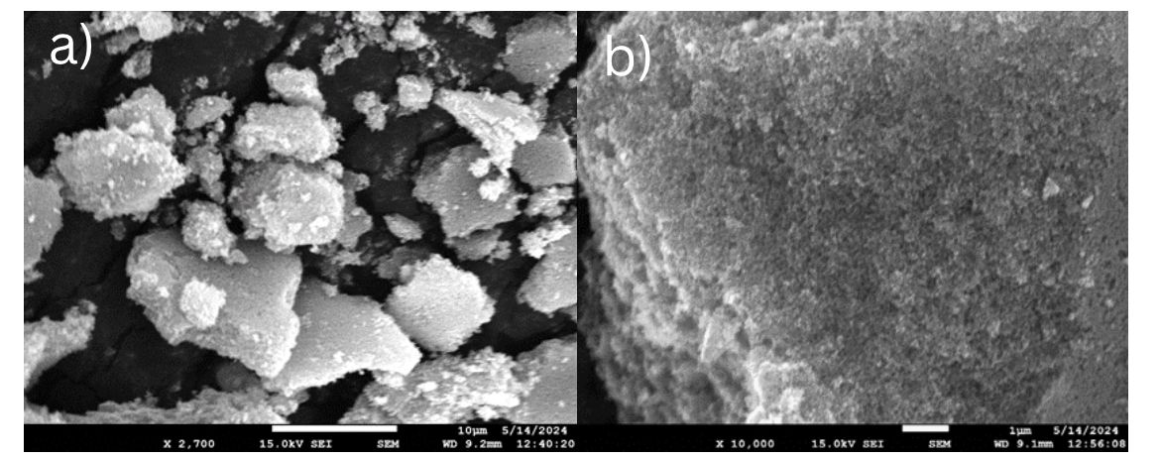

**Fig 5.** FESEM micrographs of (a) NiCoMnS4; Precursor ratio: N:C:M:S = 1:1:1:8; M = 2700X (b) NiCoMnS4; Precursor ratio : N:C:M:S = 1:1:1:8; M = 10,000X

**3.3 Cyclic Voltammetry results  
 3.3.1 MXene (Ti3C2F)–Mn3O4 nanocomposites**

**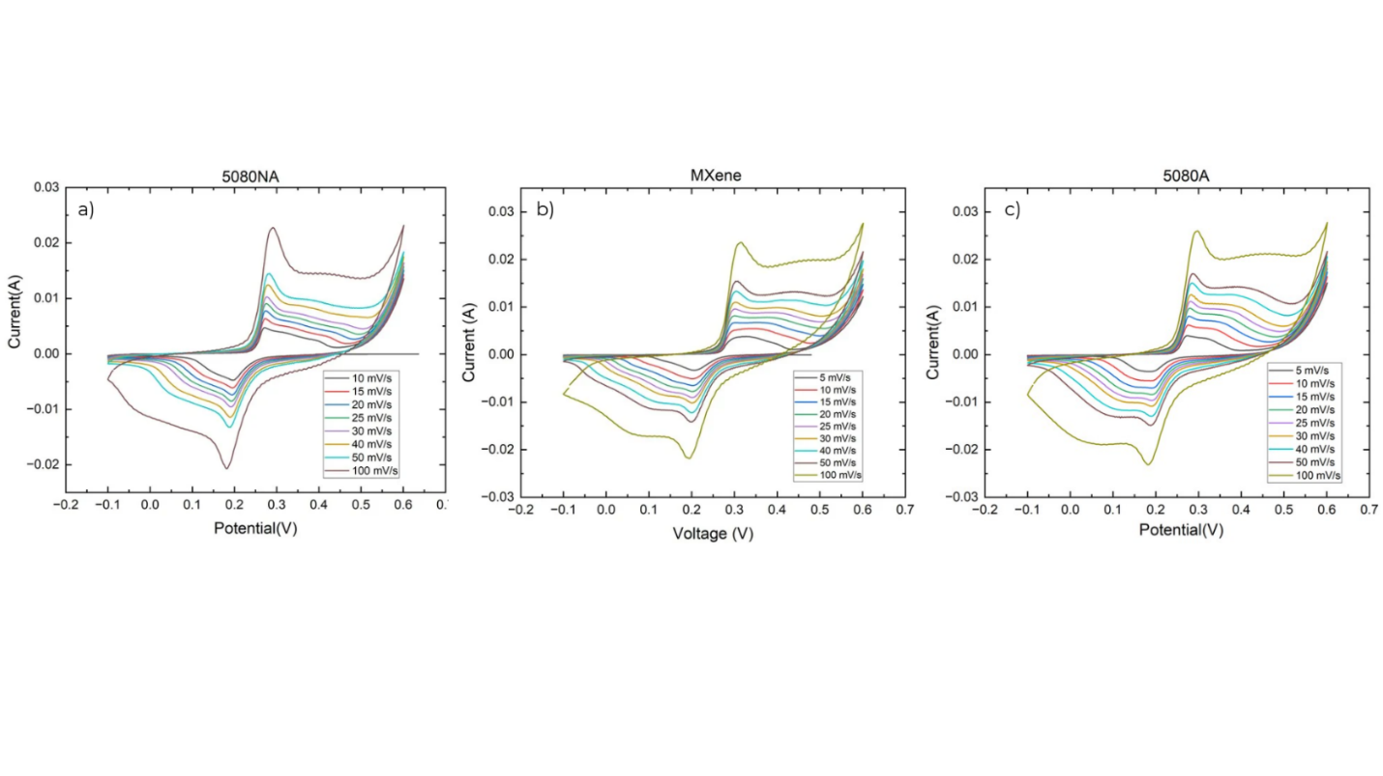   
Fig 6.** CV graphs of (a) CV graph 50 mg MXene + 80 mg KMnO4 Sample (b) CV graph of MXene (Ti3C2F) (c) CV graph of 50 mg MXene + 80 mg KMnO4 Sample; Heat treated at 120 ℃

The electrochemical performance of MXene (Ti3C2-F) and all two of theMXene (Ti3C2-F)–Mn3O4 nanocomposites, namely 50 mg MXene + 80 mg KMnO4 Sample (Heat treated at 120 ℃) and 50 mg MXene + 80 mg KMnO4 Sample (Dried at 60 ℃) were analyzed in an aqueous 3M NaOH electrolyte in a three-electrode configuration. CV performed at scan rates of 5-100 mV/s for 50 mg MXene + 80 mg KMnO4 Sample (Dried at 60 ℃) (Fig. 5(a)), MXene (Fig. 5(b)), and 50 mg MXene + 80 mg KMnO4 Sample (Heat treated at 120 ℃) (Fig. 5(c)) represents the chemically reversible faradaic reaction for all the samples.

In all three CV graphs, due to the aggravated polarization, which originates from the inadequacy of ion diffusion rate to fulfill electronic neutralization in the redox process, a shift of the anodic and cathodic peaks potentials in the positive and negative directions is observed with increasing scan rate. It has been noticed that this shift occurs in both the positive and negative orientations. There is a correlation between the increasing scanning rate and an improvement in the intensities of the redox peaks in all three CV graphs.

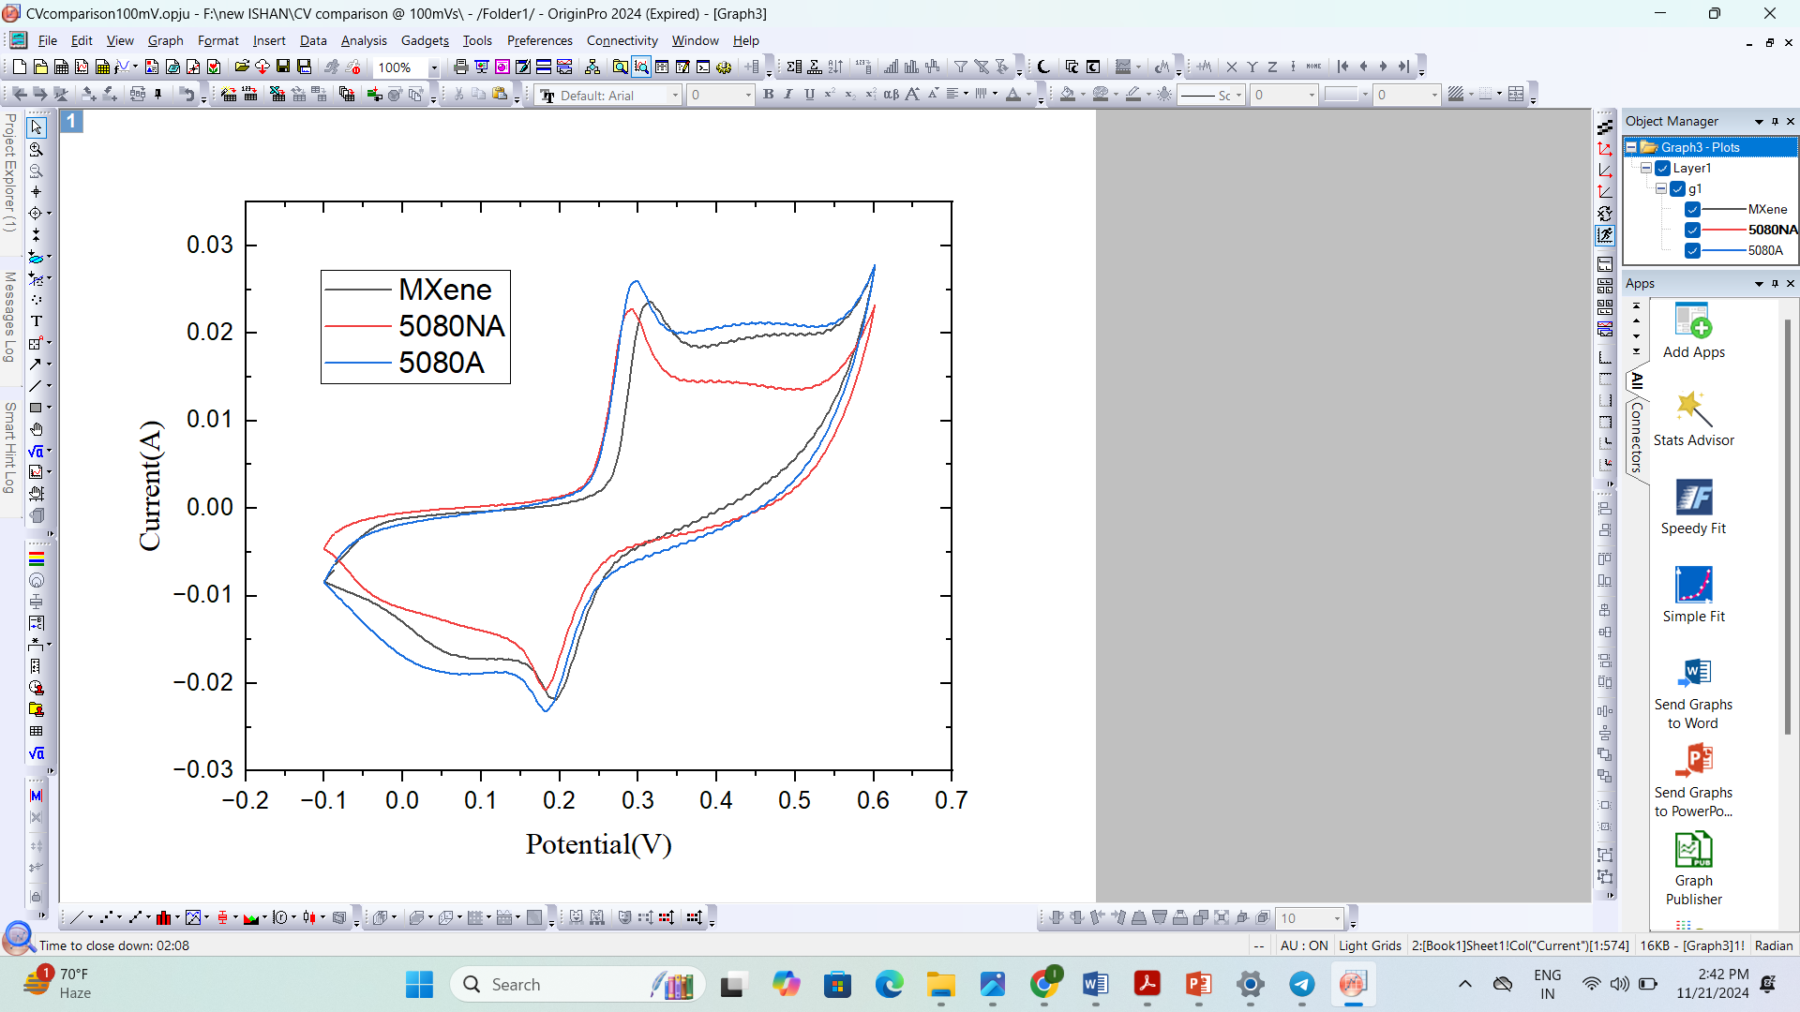

**Fig 7.** CV graphs @ 100mV/s of (a) CV graph 50 mg MXene + 80 mg KMnO4 Sample (b) CV graph of MXene (Ti3C2F) (c) CV graph of 50 mg MXene + 80 mg KMnO4 Sample; Heat treated at 120 ℃.

The CV graphs of three samples: 50 mg MXene + 80 mg KMnO4, MXene (Ti3C2-F), and 50 mg MXene + 80 mg KMnO4, heat-treated at 120 ℃, are presented in a single graph. A comparative analysis is conducted here, with peak currents of 0.229 A, 0.236 A, and 0.0259 A, respectively. The likely explanation for the increased current in the heat-treated composite is that the precursors underwent sufficient time and temperature during heat treatment for phase formation, resulting in the successful incorporation of Mn3O4 2D sheets between the MXene sheets.

**3.4 Galvanostatic charge-discharge (GCD) Analysis  
 3.4.1 MXene (Ti3C2F)–Mn3O4 nanocomposite**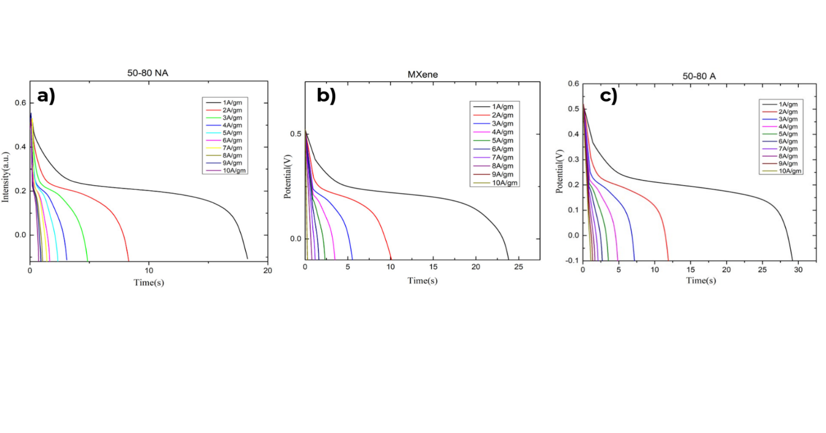

**Fig 8.** GCD graphs (a) GCD graph 50 mg MXene + 80 mg KMnO4 Sample (b) GCD graph of MXene (Ti3C2-F) (c) GCD graph of 50 mg MXene + 80 mg KMnO4 Sampl; Heat treated at 120 ℃.

Galvanostatic charge-discharge (GCD) studies were performed at various current densities from 1 to 10 A/g for all samples to study the performance of electrochemical energy storage. The GCD curves of 50 mg MXene + 80 mg KMnO4 sample (Fig. 7(a)), MXene (Ti3C2-F) (Fig. 7(b)), 50 mg MXene + 80 mg KMnO4 Sample; Heat treated at 120 ℃ (Fig. 7(c), exhibits non-linear charge/discharge behaviors with a slight plateau, indicating a process similar to faradaic diffusion-limited and the pseudocapacitive type, which is also similar to the observations of CV curves.

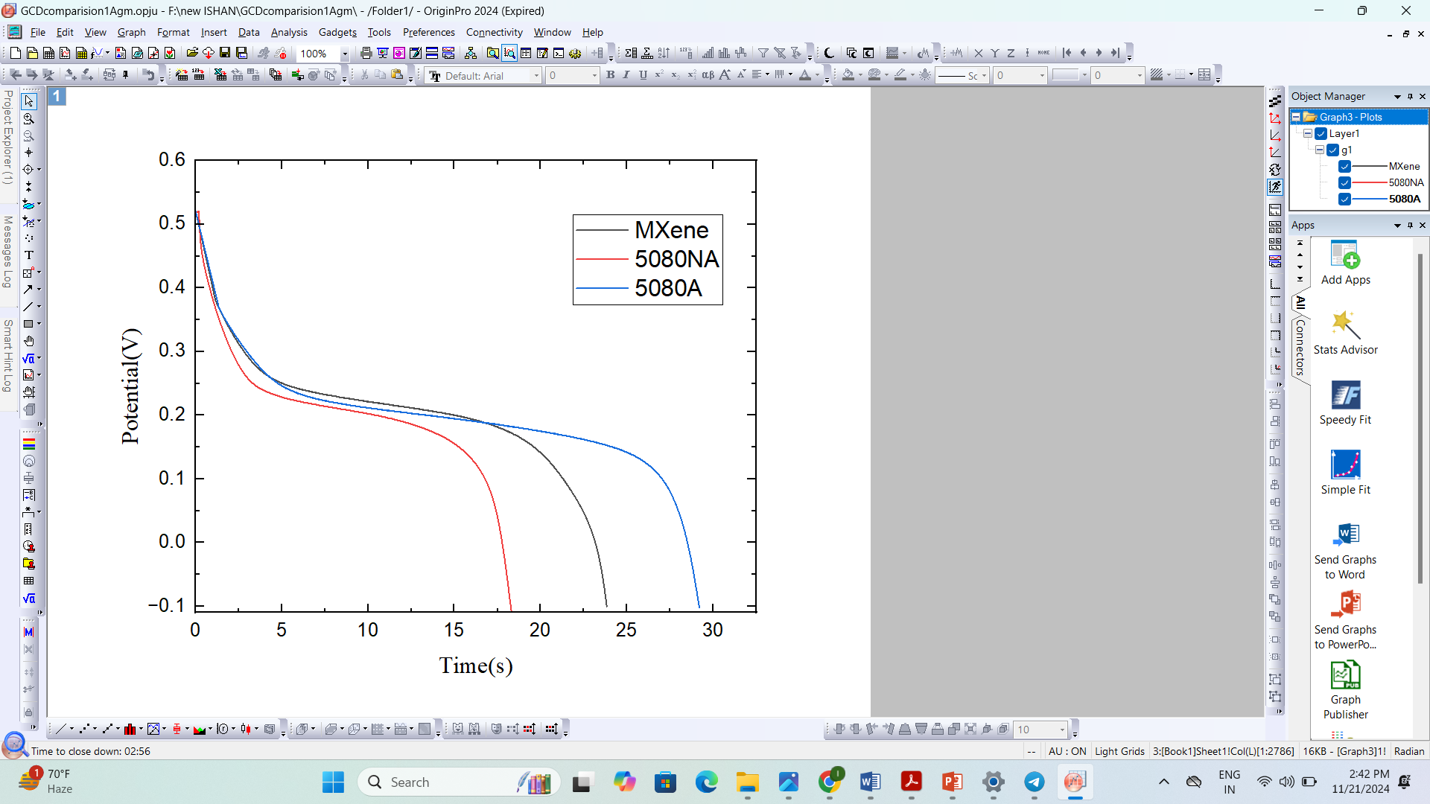

**Fig 9.** GCD graphs @ 1A/gm of (a) GCD graph 50 mg MXene + 80 mg KMnO4 Sample (b) GCD graph of MXene (Ti3C2F) (c) GCD graph of 50 mg MXene + 80 mg KMnO4 Sample; Heat treated at 120 ℃.

The GCD graphs of three samples: 50 mg MXene + 80 mg KMnO4, MXene (Ti3C2-F), and 50 mg MXene + 80 mg KMnO4, heat-treated at 120 ℃, are presented in a single graph. A comparative analysis is conducted here, with discharge times of 18.258 s, 23.904 s, and 29.298 s, respectively. The likely explanation for the increased current in the heat-treated composite is that the precursors underwent sufficient time and temperature during heat treatment for phase formation, resulting in the successful incorporation of Mn3O4 2D sheets between the MXene sheets.

**3.4.2. Calculations:**

Specific capacitance can also be quantified by the discharge curve of GCD,

where, is the specific capacitance (F/g), is the mass loading of the electrode (g), is the potential window (V), and is the discharge current (A).



**Fig 10.** Specific Capacitance Vs Current density graphs (a) Graph of 50 mg MXene + 80 mg KMnO4 Sample (b) Graph of MXene (Ti3C2F) (c) Graph of 50 mg MXene + 80 mg KMnO4 Sample; Heat treated at 120 ℃.

Here theSpecific Capacitance Vs Current density graphs are made for the following samples:   
50 mg MXene + 80 mg KMnO4 Sample, MXene (Ti3C2F) and 50 mg MXene + 80 mg KMnO4 Sample; Heat treated at 120 ℃. The specific capacitance of the heat-treated sample remained highest throughout the current density range.

The reason is likely explanation for the increased current in the heat-treated composite is that the precursors underwent sufficient time and temperature during heat treatment for phase formation, resulting in the successful incorporation of Mn3O4 2D sheets between the MXene sheets.

**Chapter 4**

**Conclusion and Future Scope**

**4.1 Conclusion**

In summary, to address the escalating energy demands, various energy sources are evaluated, most of which depend on fossil fuel consumption, resulting in the dual issues of resource depletion and environmental damage. The utilization of renewable energy necessitates energy storage systems to retain this energy. Batteries, while vital energy storage systems, possess disadvantages such as poor power densities, flammability, and overheating concerns. Supercapacitors demonstrate significant potential in this field because of their high power density, facilitating rapid charge and discharge rates, however continuous research to enhance their energy densities remains crucial.

Firstly MXene was synthesized as follows, Ti₃AlC₂ MAX phase was transformed into Ti₃C₂-F MXene by HF etching. One gram of MAX phase was subjected to a reaction with 20 mL of 40% HF at 50 °C for 24 hours under agitation. The pH of the mixture was neutralized using deionized water, thereafter undergoing ethanol-assisted centrifugation at 4000 rpm. The resulting MXene was dried overnight at 70 °C, producing ≥85% Ti₃C₂-F MXene. No further delamination using lithium chloride was conducted, leading to well-aligned MXene sheets.

Nanocomposites were made as follows: MnO₂/MXene nanocomposites were produced via the hydrothermal technique. A combination of 50 mg MXene in 30 mL deionized water was agitated at ambient temperature, then including 80 mg KMnO₄ and stirred at 90°C for 30 minutes. The solution was subsequently heated to 140°C in a Teflon-lined autoclave for a duration of 4 hours. The product underwent washing with deionized water and ethanol, was centrifuged at 4000 rpm, and subsequently vacuum-dried at 60°C for 4 hours. Further samples were created by altering MXene, KMnO₄, and drying duration to investigate their impact on composite production and electrochemical characteristics.

Two nanocomposites, specifically, 50 mg MXene + 80 mg KMnO4 Sample and 50 mg MXene + 80 mg KMnO4 Sample, were subjected to heat treatment at 120 ℃ and subsequently analyzed using electrochemical techniques, including cyclic voltammetry (CV) and galvanostatic charge-discharge (GCD). In both of these measurements, we have gained the conclusion that 50 mg MXene + 80 mg KMnO4 Sample; Heat treated at 120 ℃ sample is the most suited one.  
Utilizing GCD, we determined the specific capacitance of all three electrodes at various current densities. From this point, we reached the same conclusion.

**4.2 Future Scope**

Further exploration for newer combinations of transition metal oxides and Different kinds of MXenes is to be done to improve our current standing on the synthesis and application of these Nanocomposites for high-performance supercapacitor electrodes. Furthermore, newer composites of MXenes with other materials could be explored, with the added benefit of strategical morphological design. Different organic electrolytes enabling wider potential windows can be looked into to improve the supercapacitor device performance.

**References:   
1.** Gnana Sundara Raj, B.; Asiri, A. M.; Wu, J. J.; Anandan, S., Synthesis of Mn3O4 nanoparticles via chemical precipitation approach for supercapacitor application. Journal of Alloys and Compounds 2015, 636, 234-240.

**2.** Kumar, Y. A.; Raorane, C. J.; Hegazy, H. H.; Ramachandran, T.; Kim, S. C.; Moniruzzaman, M., 2D MXene-based supercapacitors: A promising path towards high-performance energy storage. Journal of Energy Storage 2023, 72, 108433.

**3.** Oyedotun, K. O.; Momodu, D. Y.; Naguib, M.; Mirghni, A. A.; Masikhwa, T. M.; Khaleed, A. A.; Kebede, M.; Manyala, N., Electrochemical performance of two-dimensional Ti3C2-Mn3O4 nanocomposites and carbonized iron cations for hybrid supercapacitor electrodes. Electrochimica Acta 2019, 301, 487-499.

**4.** Zhang, J.; Yao, Z.; Zou, W.; Shen, Q.; Fan, M.; Ma, T., Trimetal NiCoMn sulfides cooperated with two-dimensional Ti3C2 for high performance hybrid supercapacitor. Journal of Solid State Chemistry 2022, 308, 122909.